- VLAN Concepts Theory

Q1. On a Cisco Packet Tracer switch, create two VLANs named 'Engineering' (VLAN 10) and 'Marketing' (VLAN 20) using the CLI commands?

Answer
- I opened Cisco Packet Tracer and selected a 2960 switch. I used the CLI to create two VLANs.
- VLAN 10 — Engineering
- VLAN 20 — Marketing
After creating both VLANs, I used the show vlan brief command to verify the configuration.
- Result: Both VLANs were created successfully on the switch.
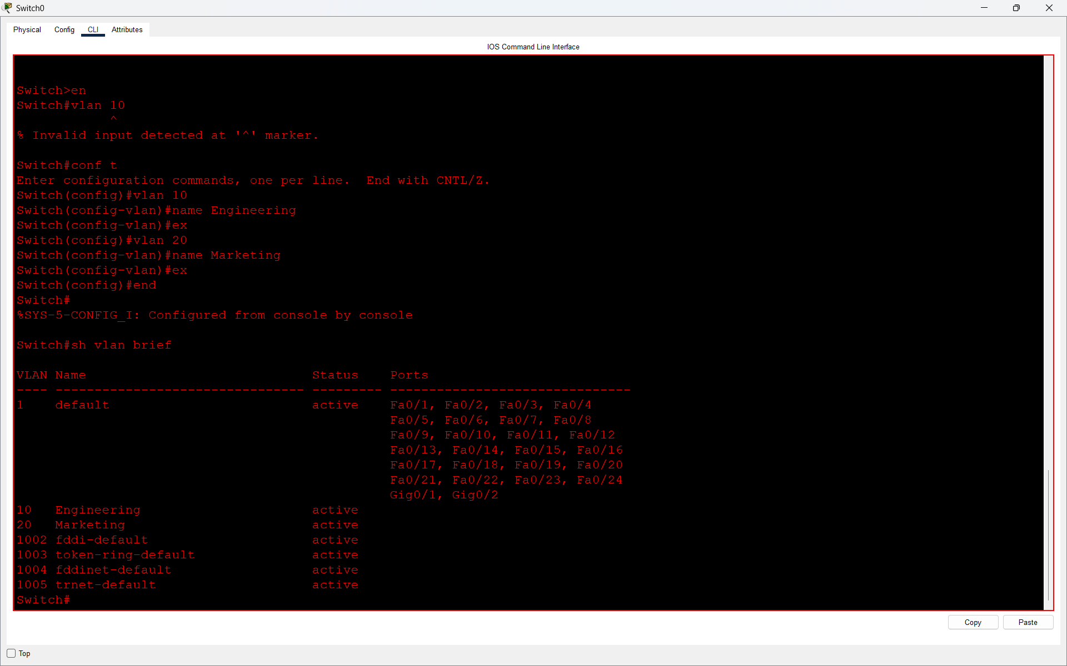

Q2. Assign ports FastEthernet0/1 and FastEthernet0/2 to VLAN 10, and ports FastEthernet0/3 and FastEthernet0/4 to VLAN 20 on your switch?

Answer
- I configured the switch ports using CLI commands in Cisco Packet Tracer.
- I assigned FastEthernet0/1 and FastEthernet0/2 to VLAN 10 (Engineering), and FastEthernet0/3 and FastEthernet0/4 to VLAN 20 (Marketing).
- I used the switchport mode access and switchport access vlan commands to assign the ports.
- After configuration, I verified the VLAN using the show vlan brief command.
- Result: All four ports were successfully assigned to their respective VLANs.
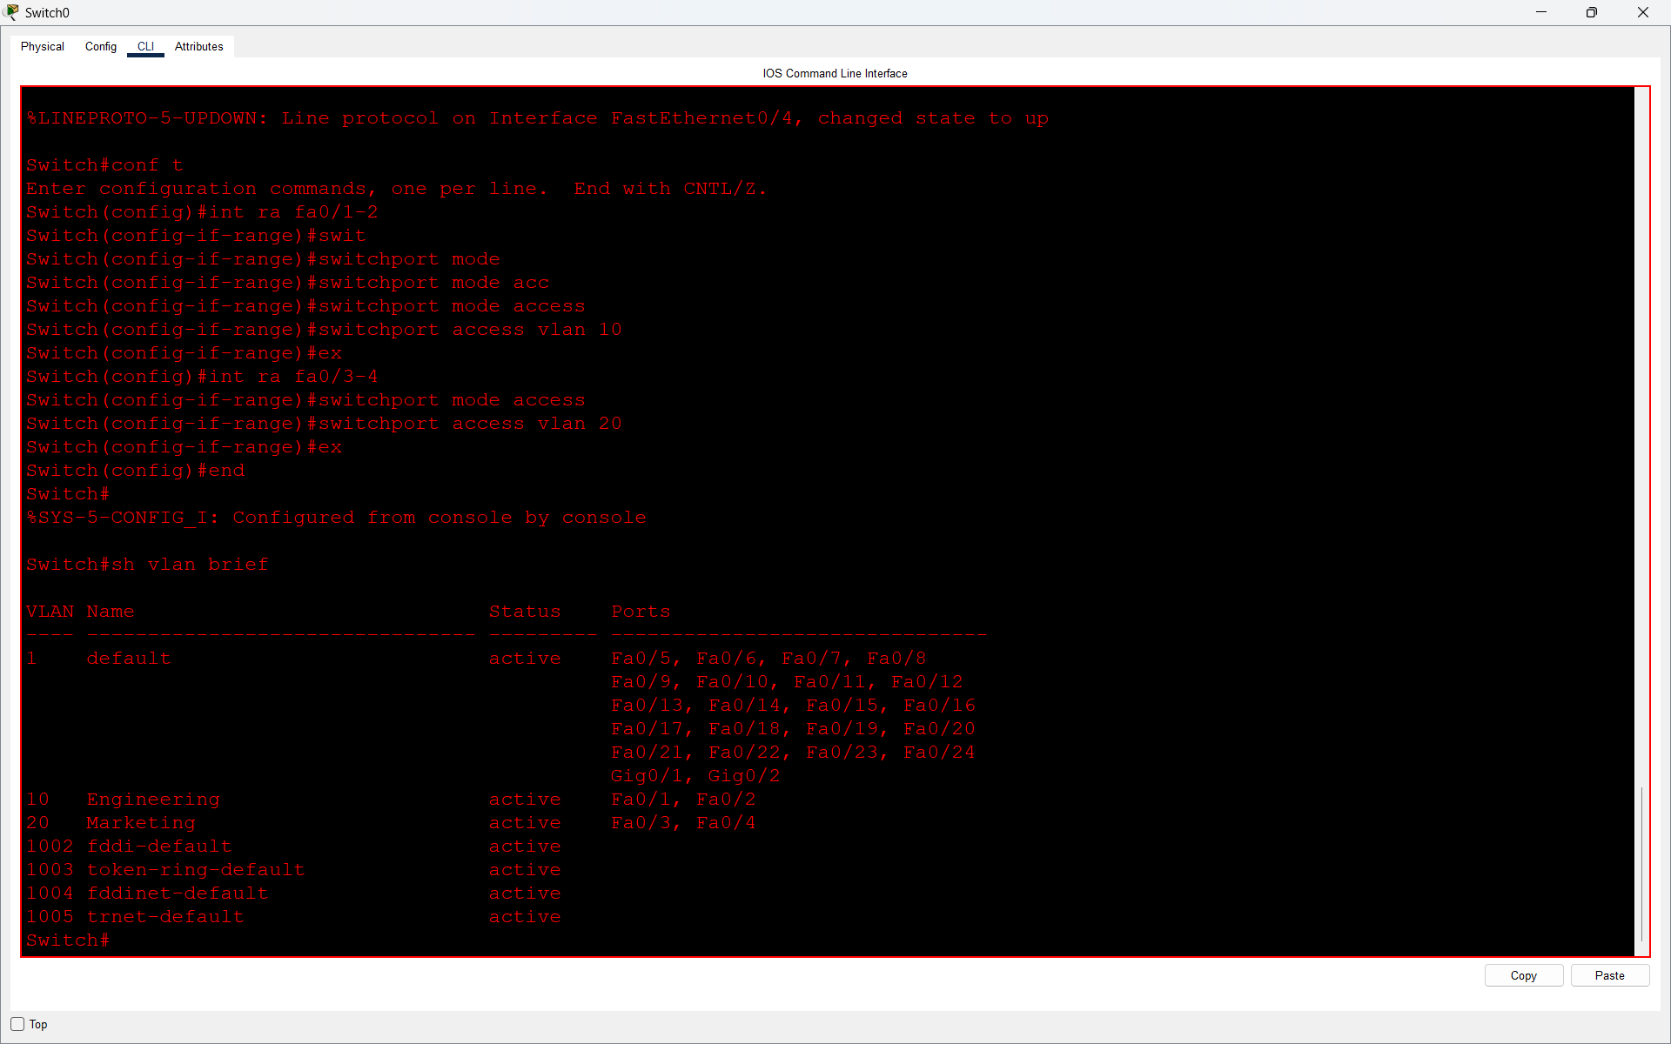

Q3. Write a short document (in a text file) listing the VLAN IDs, names, and the ports assigned to each VLAN from your configuration?

Answer
- I created a text file containing the VLAN IDs, VLAN names, and assigned ports from my Cisco Packet Tracer configuration.
- The file includes VLAN 10 (Engineering) with ports Fa0/1 and Fa0/2, and VLAN 20 (Marketing) with ports Fa0/3 and Fa0/4.

- Result: The VLAN configuration details were successfully documented in a text file.


Q4. Explain, in your own words, two benefits of using VLANs in a college campus network that has separate labs for coding and networking?

Answer
- VLAN (Virtual Local Area Network) is used to divide a physical network into separate logical networks.
1. Improved Security
VLANs provide better security by separating different departments or labs into different networks.
Example: In a college, the Coding Lab can use VLAN 10 and the Networking Lab can use VLAN 20. This helps prevent unauthorized communication between the two labs.
2. Reduced Network Traffic
VLANs reduce unnecessary broadcast traffic by dividing a large network into smaller broadcast domains.
Example: If students in the Coding Lab are using the network, their broadcast traffic will not disturb the Networking Lab because both labs are in separate VLANs.
- Conclusion:
VLANs help improve network security, reduce unnecessary traffic, and make college networks easier to manage.

